Interactive Intelligence
CIC 2015 R3
Configuration Guide

Performed By


tekVizion PVS, Inc.
Contact: 214-242-5900
www.tekvizion.com

Revision: | 1.2
Date: | 11/16/2015

Copyright © 2015 by tekVizion PVS, Inc.
All Rights Reserved.

Confidential Information
The information contained in this document is confidential and proprietary to tekVizion PVS, Inc. Its purpose is to communicate the overall strategy of an Interoperability Test Plan used by tekVizion Labs.

This document is the property of, and is proprietary to tekVizion. It is not to be disclosed in whole or in part without the express written authorization of tekVizion, shall not be duplicated or used, in whole or in part, for any purpose other than to evaluate the proposed scope of testing under contemplation.

TEKVIZION, TEKVIZION PVS, AND TEKVIZION LABS ARE TRADEMARKS OF TEKVIZION PVS, INC.
Document Revision History
Version | Reason for Change | Date | Created/Updated by
1.1 | Initial Release | 7/24/2015 | Padam Singh and Pradeep Gali
1.2 | General revisions; clean up | 11/16/2015 | Rachel Jerome

Table of Contents
1 Introduction 4
2 Network Topology 5
3 System Components 6
3.1 Hardware Components 6
3.2 Software Requirements 6
3.3 Features 6
3.3.1 Features Supported 6
3.3.2 Features Not Supported 6
3.4 Caveats 6
4 CIC Server Trunk Configuration 7
4.1 Trunk (Line) Configuration 7
4.1.1 Set Server IP Address 7
4.1.2 Line Configuration 8
4.1.3 Line Groups 30
5 Sangoma SBC Configuration 32
5.1 IP Address Assignment 32
5.2 SIP Profiles 33
5.2.1 ITSP-Side SIP Profile 33
5.2.2 CIC Server SIP Profile 38
5.3 SIP Trunks 43
5.3.1 ITSP Side SIP Profile 43
5.3.2 Primary CIC Server SIP Trunk 46
5.3.3 Backup CIC Server SIP Trunk 49
5.4 Call Routing 52
5.4.1 Verizon Trunk Routing 52
5.4.2 CIC Server-Side Routing 53
5.4.3 Default Route 54
5.5 Domain Settings 55

Table of Figures
Figure 1: Network Topology 5
Figure 2: Server IP Address 7
Figure 3: Line Configuration 8
Figure 4: Line Configuration - Cont. 9
Figure 5: Line Configuration - Cont. 10
Figure 6: Line Configuration - Cont. 11
Figure 7: Line Configuration - Cont. 12
Figure 8: Line Configuration - Cont. 13
Figure 9: Line Configuration - Cont. 14
Figure 10: Line Configuration - Cont. 15
Figure 11: Line Configuration - Cont. 16
Figure 12: Line Configuration - Cont. 17
Figure 13: Line Configuration - Cont. 18
Figure 14: Line Configuration - Cont. 19
Figure 15: Line Configuration - Cont. 20
Figure 16: Line Configuration - Cont. 21
Figure 17: Line Configuration - Cont. 22
Figure 18: Line Configuration - Cont. 23
Figure 19: Line Configuration - Cont. 24
Figure 20: Line Configuration - Cont. 25
Figure 21: Line Configuration - Cont. 26
Figure 22: Line Configuration - Cont. 27
Figure 23: Line Configuration - Cont. 28
Figure 24: Line Groups 29
Figure 25: Line Groups - Cont. 29
Figure 26: Line Groups - Cont. 30
Figure 27: Assign IP Address 31
Figure 28: Assign IP Address – Cont. 31
Figure 29: SIP Profile 32
Figure 30: SIP Profile - Cont. 33
Figure 31: SIP Profile - Cont. 34
Figure 32: SIP Profile - Cont. 35
Figure 33: SIP Profile - Cont. 36
Figure 34: SIP Profile - Cont. 37
Figure 35: SIP Profile - Cont. 38
Figure 36: SIP Profile - Cont. 39
Figure 37: SIP Profile - Cont. 40
Figure 38: SIP Profile - Cont. 41
Figure 39: SIP Trunk 42
Figure 40: SIP Trunk - Cont. 43
Figure 41: SIP Trunk - Cont. 44
Figure 42: SIP Trunk - Cont. 45
Figure 43: SIP Trunk - Cont. 46
Figure 44: SIP Trunk - Cont. 47
Figure 45: SIP Trunk - Cont. 48
Figure 46: SIP Trunk - Cont. 49
Figure 47: SIP Trunk - Cont. 50
Figure 48: Call Routing 51
Figure 49: Call Routing - Cont. 52
Figure 50: Call Routing - Cont. 53
Figure 51: Domain Settings 54
Figure 52: Domain Settings - Cont. 54

Introduction
This configuration guide describes how to configure an Interactive Intelligence (ININ) CIC 2015 R3 SERVER with SANGOMA SBC for connectivity to the VERIZON SIP Trunking service. The deployment model covered in this configuration guide is CIC 2015 R3 SERVER with SANGOMA SBC to PSTN via VERIZON SIP Trunking.
The configuration of CIC 2015 R3 SERVER detailed in this document is based on a lab environment with a simple dial-plan used to ensure proper interoperability between Sangoma SBC and VERIZON SIP network.
Verizon is offering alternative methods to connect to the PSTN via their IP network, using SIP as their primary signaling method and a centralized IP to TDM gateway. VERIZON SIP Trunking allows connection to the PSTN offering the end customers an alternative to traditional PSTN connectivity via either Analog or T1 lines. Sangoma SBC provides demarcation, security, interworking and session management services between the SIP Trunking services and customer owned services.
Testing was performed by TekVizion Labs, an independent testing and certification facility, in accordance to the ININ Certification Test Plan. Key features verified are:
- New services install processes
- Call capabilities (various features, basic call operations, local calling, domestic long distance calling and international calling)
- FAX
- Out-of-band DTMF
- Conference Calls

The configuration described in this document details the critical commands to have enabled for interoperability to be successful.
This Configuration Guide details the configuration used for connectivity to the VERIZON Service. This document serves as guidance for the integration, but does not guarantee interoperability for every use case or release combinations.

Network Topology

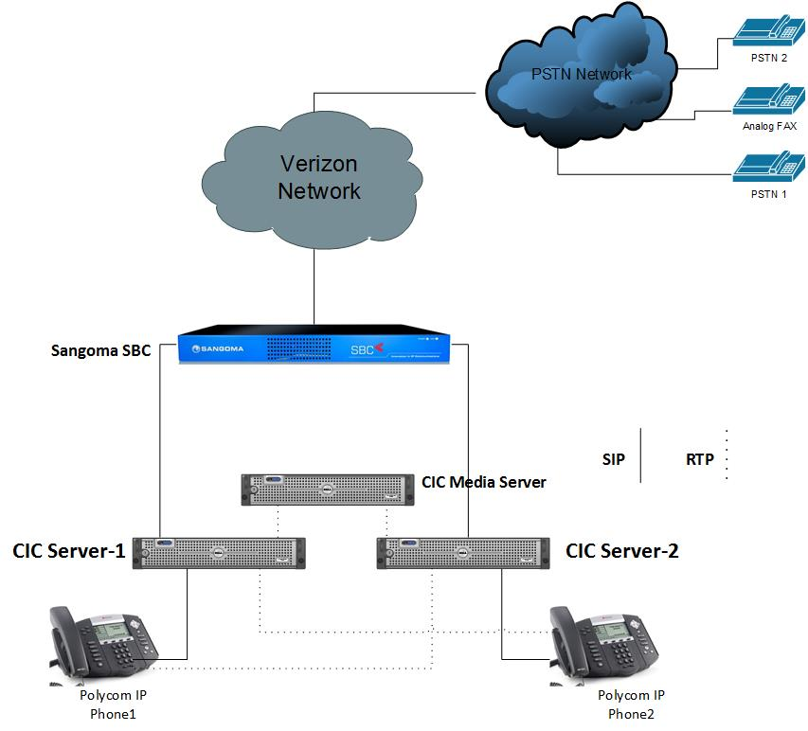

Figure 1: Network Topology

System Components

Hardware Components
- Sangoma SBC
- ININ CIC Media Server
- ININ CIC 2015 Servers
- Polycom IP 450 and IP 335 Phones

Software Requirements
- Software Load: ININ CIC 2015 R3
- Sangoma SBC Version: 2.2.1

Features

Features Supported
- Voice calls using G.711 codec
- RFC 3261 support
- Calling number presentation / restriction
- Call conferencing
- Call transfer (attended, unattended & blind transfer)
- Call hold and resume
- Call forwarding
- CIC Server Switchover

Features Not Supported
- WAN Managed Phones
- TLS/SRTP

Caveats
- None

CIC Server Trunk Configuration

Trunk (Line) Configuration

Set Server IP Address
- Navigate to Start > Control Panel > Network and Internet > View network status and tasks > Change Adapter Settings > Ethernet > Ethernet Status > Properties > Internet Protocol Version 4(TCP/IP4) > Properties
- Select Use the Following IP Address
- Set IP Address: Enter the IP address assigned for the CIC server. 10.64.4.4 is used in this example.
- Set Subnet mask: 255.255.0.0 is given for this example
- Set Default Gateway: 10.64.1.1 is used for this example
- Select Use the following DNS server addresses
- Set Preferred DNS Server: 10.64.3.39 is used for this example. The computer is placed in this domain for this example.
- Set Alternate DNS Server: 10.64.1.3 is used for this example. This is the DNS server for Enterprise network.
- Click OK
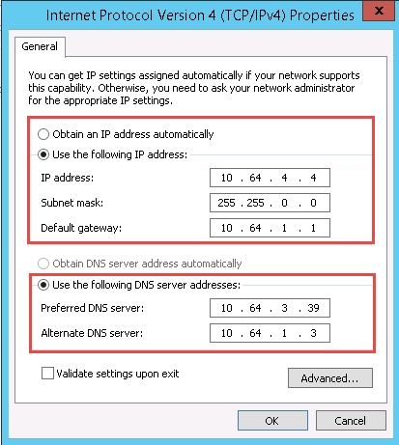
Figure 2: Server IP Address

Line Configuration
- In Interaction Administrator: Navigate to CICSERVER1 – 2015 R3 > Lines
- Double Click on Lines and select New
- Set Line Name: Sangoma SBC is given for this example
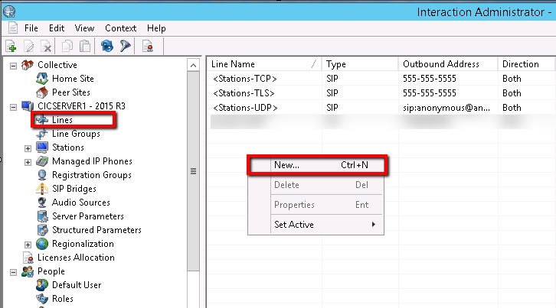
Figure 3: Line Configuration

- Select the SIP Line Configuration tab
- Select Line in left pane
- Set Line Usage: Station Connections is selected from the drop down menu
- Set Domain Name: Enter the FQDN of the server provided at the domain controller. This FQDN should be able to resolve both the primary server and switchover server IP Addresses. CICServer1.tekviziondomain.com is given for this example.
- Enable Fax Detection: Checked
NOTE: Fax Protocols T30 & T38 are both supported
- All the other values are set to default values

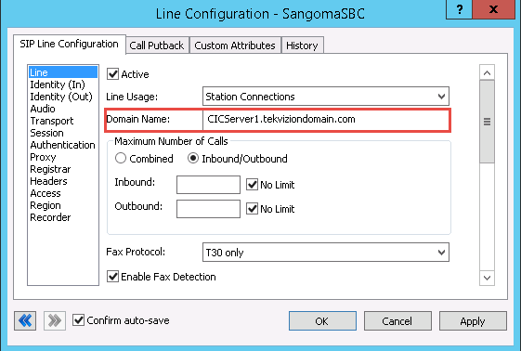
Figure 4: Line Configuration - Cont.

- All other values are set to default values

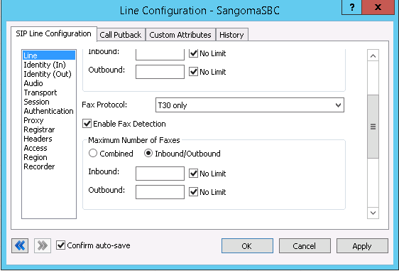
Figure 5: Line Configuration - Cont.

- All other values are set to default values
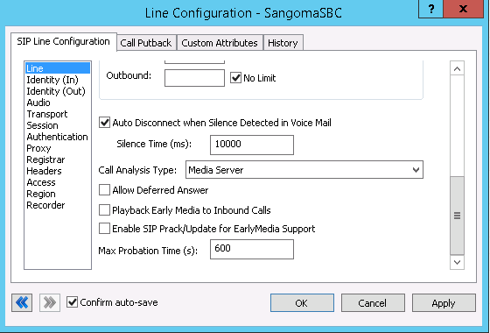
Figure 6: Line Configuration - Cont.

- Select Identity (In) in left pane
- All the values are set to default values

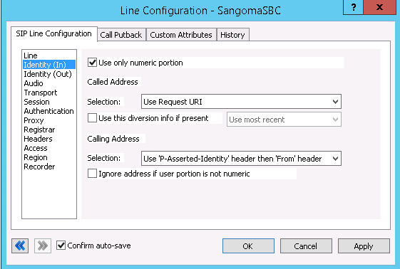
Figure 7: Line Configuration - Cont.

.

- Select Identity (Out) in left pane
- Set Line Value 1: Name is given as Sangoma and Address is given as 7192083390@CICServer1.tekviziondomain.com (This is Pilot number for the given DID range by ITSP)
- All other values are set to default values

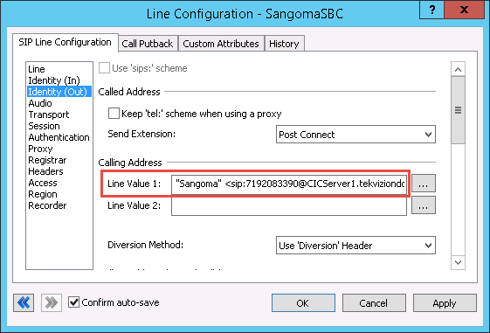
Figure 8: Line Configuration - Cont.
.

- All the values are set to default values

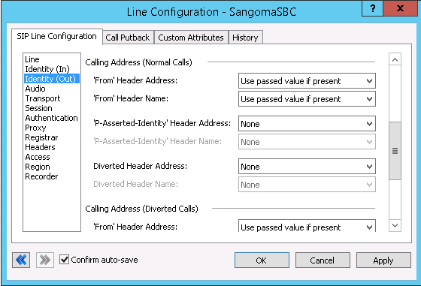

Figure 9: Line Configuration - Cont.

- All the values are set to default values
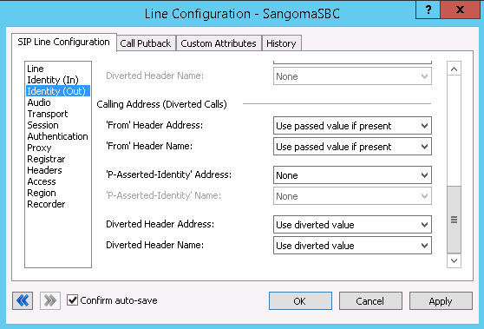
Figure 10: Line Configuration - Cont.

- Select Audio in left pane
- Set Audio Path: Always In is selected from drop down menu. This disables the Media Bypass.
- Set DTMF Type: RFC2833 if supported, otherwise inband is selected from drop down menu
- Set DTMF Payload: 101 is selected for this example
- All the values are set to default values

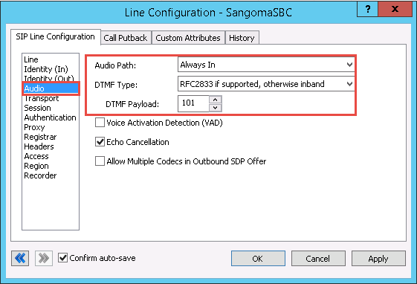
Figure 11: Line Configuration - Cont.

- Select Transport in left pane
- All the values are set to default values

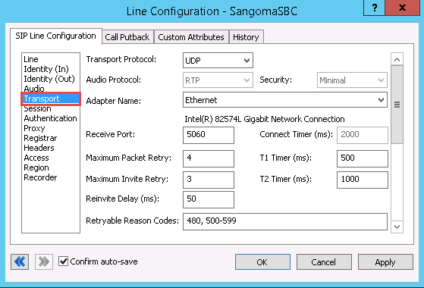
Figure 12: Line Configuration - Cont.

- All the values are set to default values

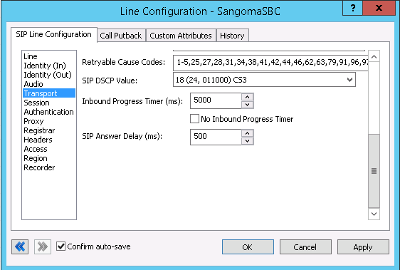
Figure 13: Line Configuration - Cont.

- Select Session in left pane
- All the values are set to default values

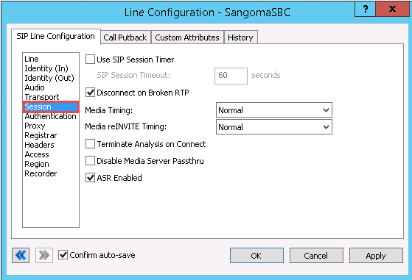
Figure 14: Line Configuration - Cont.

- Select Authentication in left pane
- All the values are set to default values

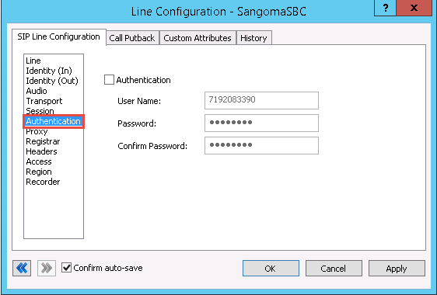
Figure 15: Line Configuration - Cont.

- Select Proxy in left pane
- Click Add
- Set Address: Enter the Address of the next hop or the Sangoma SBC LAN IP address. 10.64.4.8 is used for this example.
- Set Port Number: 5060 is given for this example
- Click OK
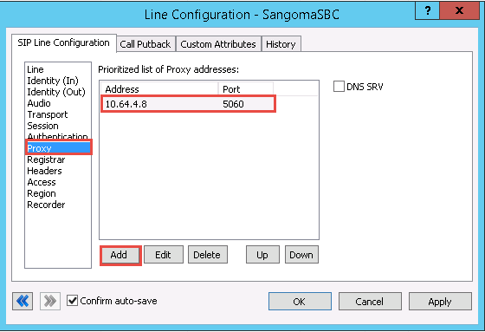
Figure 16: Line Configuration - Cont.

- Select Registrar in left pane
- All the values are set to default values

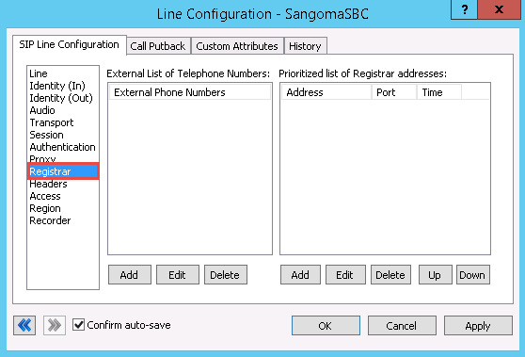
Figure 17: Line Configuration - Cont.

- Select Headers in left pane
- All the values are set to default values

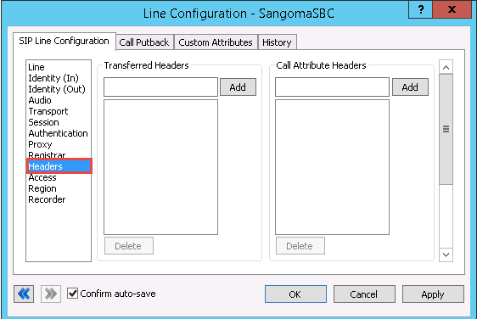
Figure 18: Line Configuration - Cont.

- Select Access in left pane
- Under All Computers will be:
- Check Denied Access
- Click Add
- Set Address: Enter the IP address of the next hop or Sangoma SBC LAN IP address. 10.64.4.8 is used for this example.
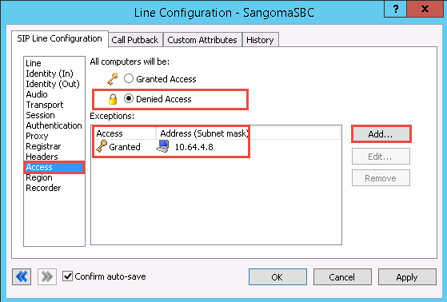
Figure 19: Line Configuration - Cont.

.
- Select Region in left pane
- All the values are set to default values

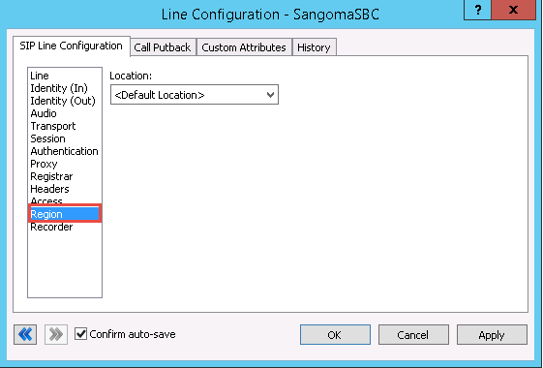
Figure 20: Line Configuration - Cont.

- Select Recorder in left pane
- All the values are set to default values

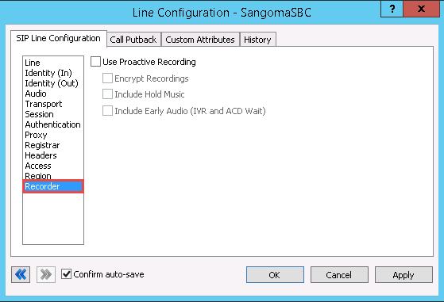
Figure 21: Line Configuration - Cont.

- Select the Call Putback tab
- Enable sending SIP REFER messages: Unchecked for Internal (Blind & Consultative) Transfers (per test cases)
- All the values are set to default values

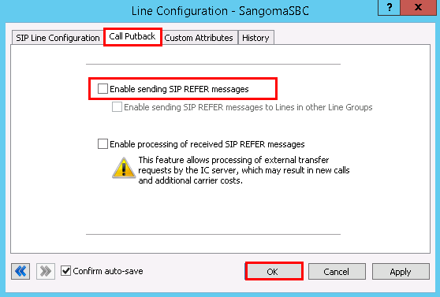
Figure 22: Line Configuration - Cont.

- Select the Custom Attributes tab
- All the values are set to default values
- Click OK

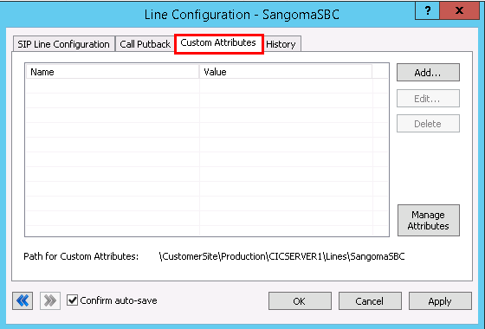
Figure 23: Line Configuration - Cont.

Line Groups
- Navigate to CICSERVER1 – 2015 R3 > Line Groups
- Right click and select New
- Set Enter the Group Name: Sangoma is given for this example
- Click OK

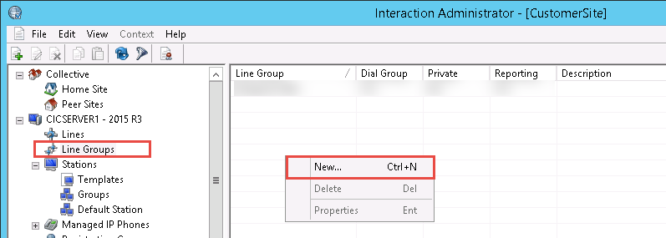
Figure 24: Line Groups
- Select the Configuration tab
- Use for Reporting: Checked
- Use as Dial Group: Checked
- Use for Private Line Assignment: Unchecked
- Set Hunt Selection Method: Select Descending Sequential
- Click OK
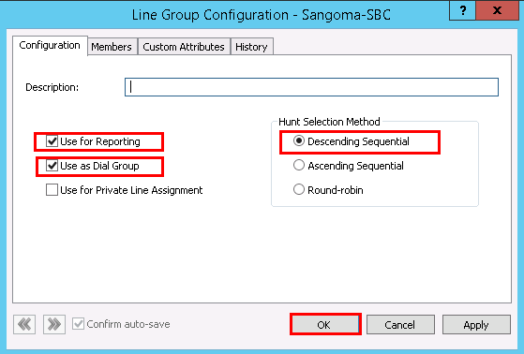
Figure 25: Line Groups - Cont.
- Select the Members tab
- From Available Lines: Select SangomaSBC and Click Add
- The Sangoma SBC Line should be moved to Currently Selected Lines as shown in the figure below
- Click Apply
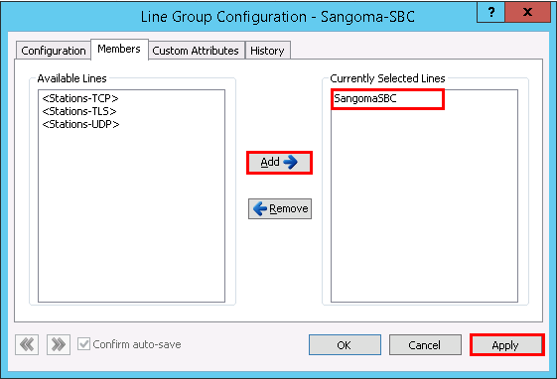
Figure 26: Line Groups - Cont.

Sangoma SBC Configuration

IP Address Assignment
- Navigate to Configuration > IP Settings > Network
- Set Interface: eth1 is selected from the drop down for this example
- Set Address: Enter the LAN IP Address of the Sangoma SBC. Please use the actual IP address for your setup. 10.64.4.8 is given for this example.
- Click Save
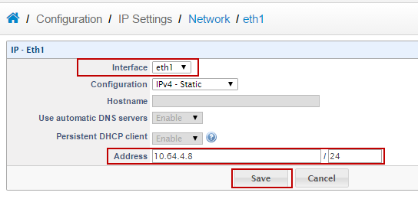
Figure 27: Assign IP Address

- Navigate to Configuration > IP Settings > Network
- Set Interface: eth2 is selected from the drop down for this example
- Set Address: Enter the WAN IP Address of the Sangoma SBC. Please use the actual IP Address for your setup provided by your carrier.192.65.79.122 is given for this example.
- Click Save
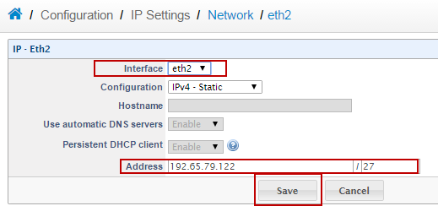
Figure 28: Assign IP Address – Cont.

SIP Profiles

ITSP-Side SIP Profile
- Navigate to Configuration > Signaling > SIP Profiles
- Click Add
- Set Profile Name: External_Verizion_SIP_Trunk_Profile is given for this example
- Click Add
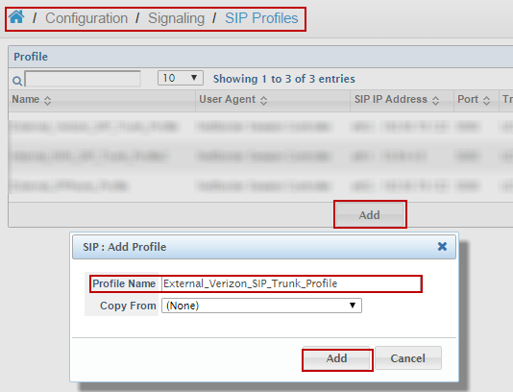
Figure 29: SIP Profile

- Navigate to Configuration > Signaling > SIP Profiles > External_Verizion_SIP_Trunk_Profile
- Set SIP IP Address: Select eth2-192.65.79.122 from the drop down menu. The IP address selected will act as the WAN side interface IP. Refer to section 5.1
- Set Transport: UDP+TCP is selected from drop down menu
- All the other options are set by default
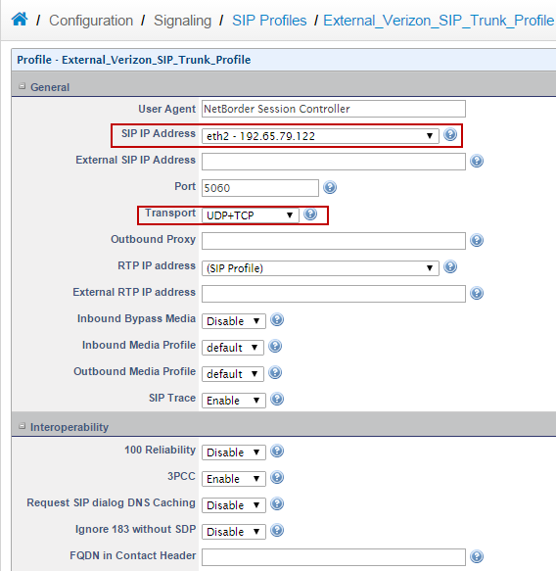
Figure 30: SIP Profile - Cont.

- All other fields are set to default values
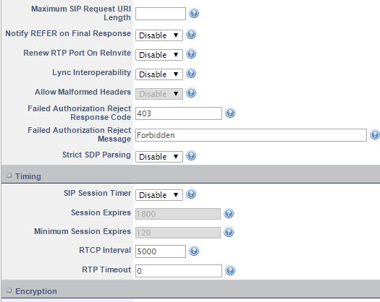
Figure 31: SIP Profile - Cont.

- Add the fields are set to default values
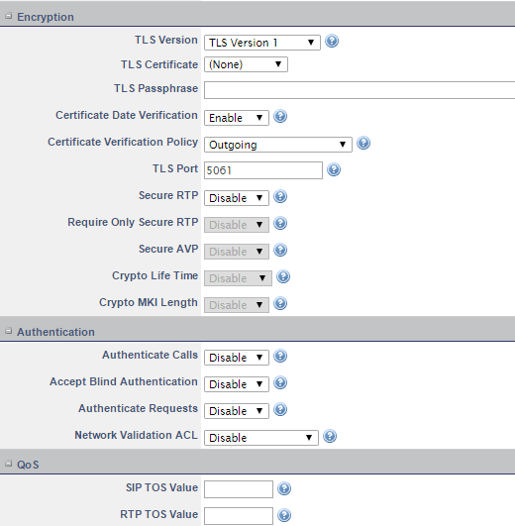
Figure 32: SIP Profile - Cont.

- Set Routing Plan: Verizon_Trunk_Ingress is selected from drop down menu. Please Refer to Section 5.4.1
- Add the other fields are set to default values
- Click Save
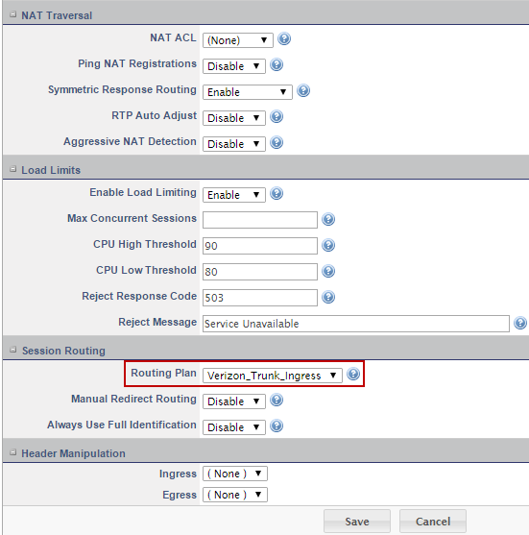
Figure 33: SIP Profile - Cont.

CIC Server SIP Profile
- Navigate to Configuration > Signaling > SIP Profiles
- Click Add
- Set Profile Name: Internal_ININ_SIP_Trunk_Profile2 is given for this example
- Click Add
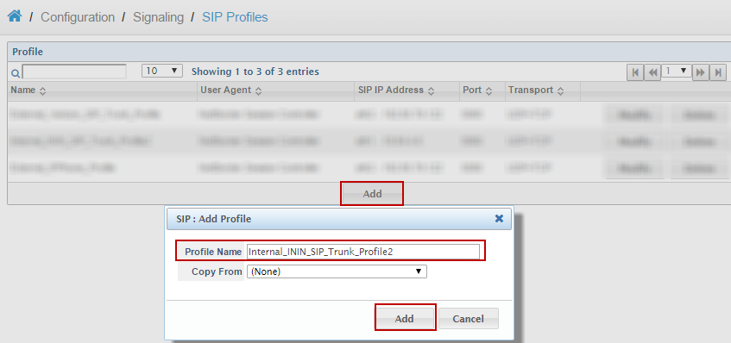
Figure 34: SIP Profile - Cont.

- Set SIP IP Address: eth1-10.64.4.8 is selected from drop down. The IP address selected will act as LAN-side interface IP. Please Refer to Section 5.1
- Set Transport: UDP+TCP is selected from drop down menu
- All the other values are set to default values
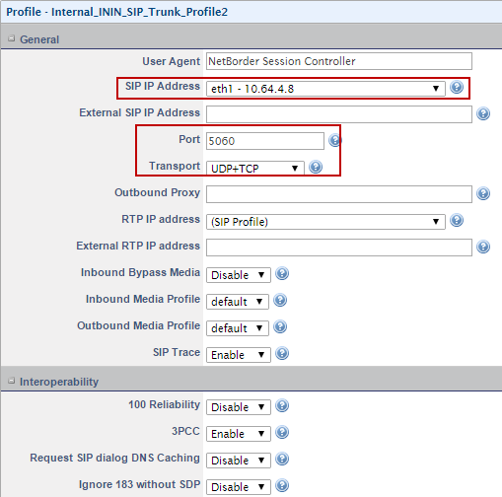
Figure 35: SIP Profile - Cont.

- All the values are set to default values

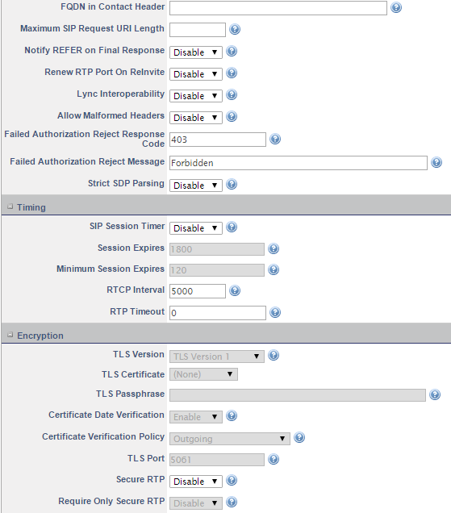
Figure 36: SIP Profile - Cont.

- All the values are set to default values

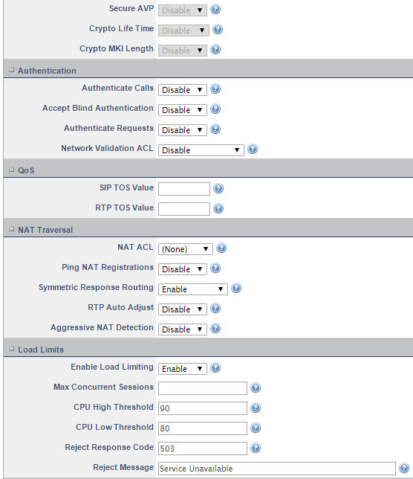
Figure 37: SIP Profile - Cont.

- Set Routing Plan: ININ_SIP_Trunk_Egress is selected from the drop down. Please Refer to Section 5.4.2
- All the other values are set to default values
- Click Save
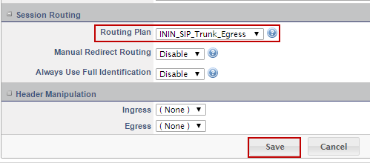
Figure 38: SIP Profile - Cont.

SIP Trunks

ITSP Side SIP Profile
- Navigate to Configuration > Signaling > SIP Trunks
- Click Add
- Set New Trunk: Verizon_SIP_Trunk
- Click Add
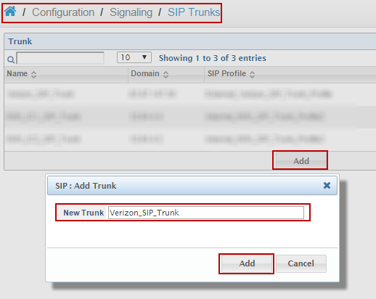
Figure 39: SIP Trunk

- Set Domain: Enter the ITSP side IP Address. For this example, the Verizon SIP trunk IP address is given.
- Set Proxy Address: Enter the ITSP IP address and port number. For this example, the Verizon SIP Trunk IP Address with Port 5073 is given.
- Set Transport: Select UDP
- Set SIP Profile: External_Verizion_SIP_Trunk_Profile is selected from drop down menu. Please Refer to Section 5.2.1
- All the other values are set to default values
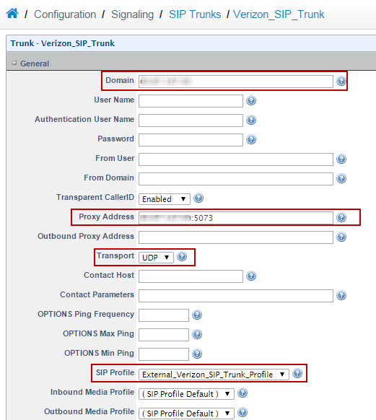
Figure 40: SIP Trunk - Cont.

- All the values are set to default values
- Click Save
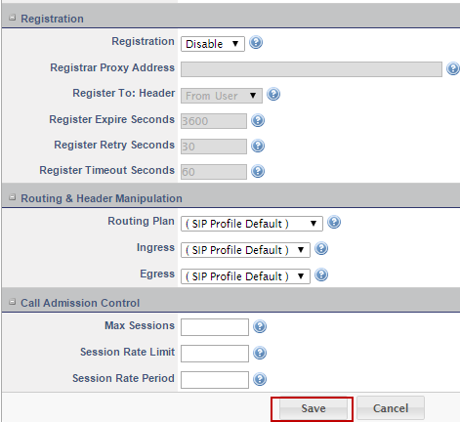
Figure 41: SIP Trunk - Cont.

Primary CIC Server SIP Trunk
- Navigate to Configuration > Signaling > SIP Trunks
- Click Add
- Set New Trunk: ININ IC1_SIP_Trunk is given for this example
- Click Add
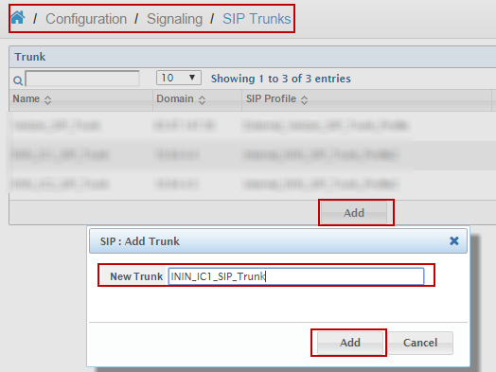
Figure 42: SIP Trunk - Cont.

- Set Domain: Enter the Primary CIC Server IP address. Please give the actual IP address for your configuration. 10.64.4.4 is given for this example.
- Set Transport: UDP
- Set SIP Profile: Internal_ININ_SIP_Trunk_Profile2 is selected from drop down menu. Please Refer to Section 5.2.2
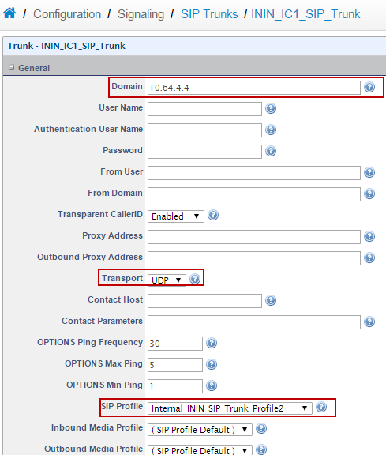
Figure 43: SIP Trunk - Cont.

- All the values are set to default values
- Click Save
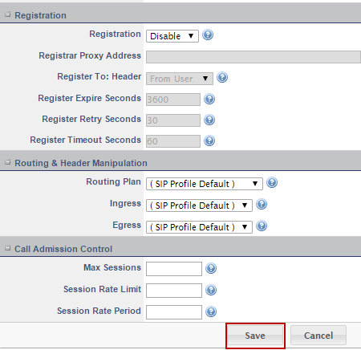
Figure 44: SIP Trunk - Cont.

Backup CIC Server SIP Trunk
- Navigate to Configuration > Signaling > SIP Trunks
- Click Add
- Set New Trunk: ININ_IC2_SIP_Trunk
- Click Add
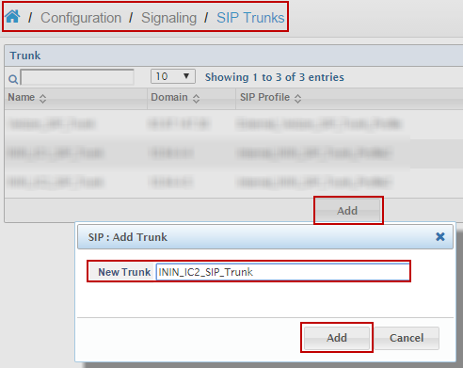
Figure 45: SIP Trunk - Cont.

- Set Domain: Enter the backup CIC Server IP address. Please use the actual IP address for your configuration. 10.64.4.5 is given for this example.
- Set Transport: UDP
- Set Profile: Internal_ININ_SIP_Trunk_Profile2 is selected from drop down menu. Please Refer to Section 5.2.3
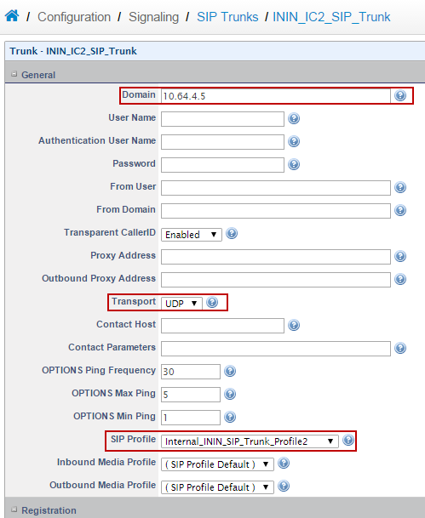
Figure 46: SIP Trunk - Cont.

- All the values are set to default values
- Click Save
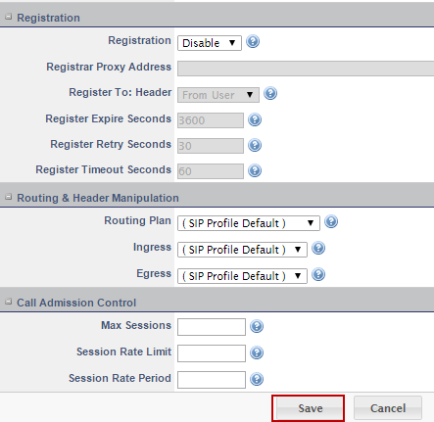
Figure 47: SIP Trunk - Cont.

Call Routing

Verizon Trunk Routing
- Navigate to Configuration > Call Routing
- Set Description: Verizon_SIP_Trunk_Ingress is given for this example
- The screenshot below displays the inbound and outbound routing and header manipulations on the WAN side Interface
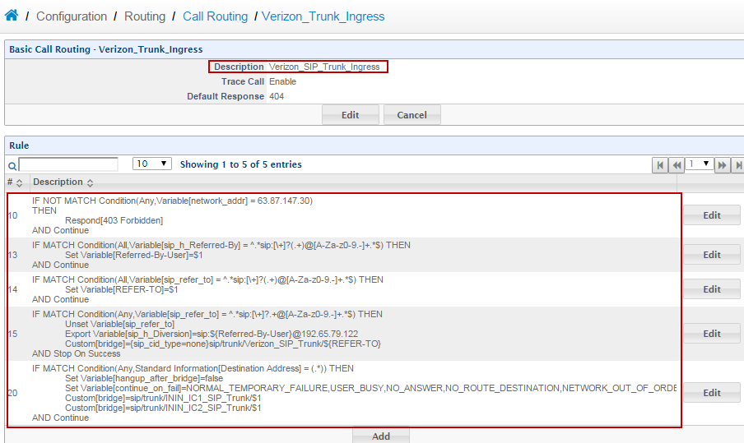
Figure 48: Call Routing

CIC Server-Side Routing
- Navigate to Configuration > Call Routing
- Set Description: ININ_SIP_Trunk_egress is given for this example
- The screenshot below displays the inbound and outbound routing and header manipulations on the LAN side Interface
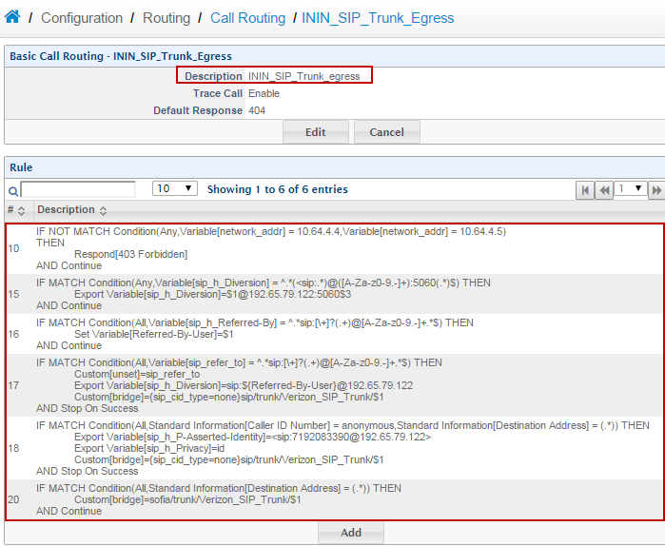
Figure 49: Call Routing - Cont.

Default Route
- Navigate to Configuration > Call Routing
- The screenshot below displays the default call routing settings
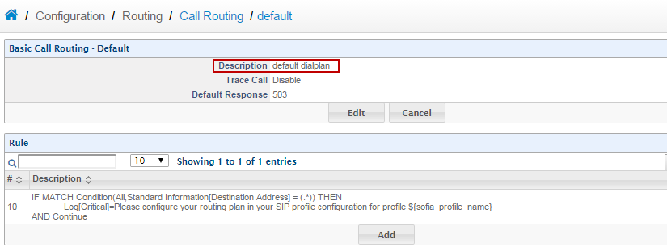
Figure 50: Call Routing - Cont.

Domain Settings
- Navigate to Configuration > Signaling > Domains
- Click Add
- Set Name Domain: cicserver.tekviziondmain.com
- Click Add
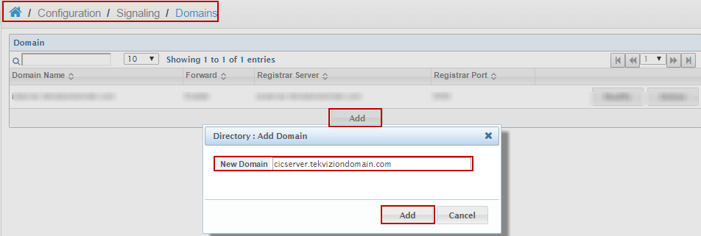
Figure 51: Domain Settings
- The setup below is for registration of WAN phones
- Set Forward SIP Profile: External_IPPhone_Profile is selected from drop down menu
- Set Forward Registrar Server: cicserver.tekviziondomain.com is used for this example
- Set Forward Registrar Server Port: 5080
- Set Transport: TCP
- Click Save
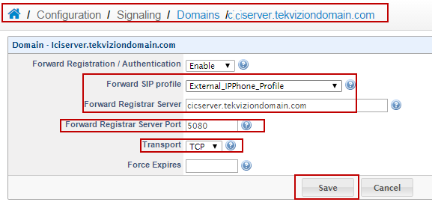
Figure 52: Domain Settings - Cont.

