Citrix XenApp 7.6
Technical Reference
CIC 2015/CIC 2016
Abstract
This document describes the various client application testing performed in a Citrix XenApp 7.6 environment.
Last Updated January 7, 2016

Contents
Copyright and Trademark Information 3
Introduction 3
Understanding application virtualization 4
Goals 4
Test Environment 5
Functional testing 6
Load Testing 6
Testing methodology 6
Load test Results 7
Appendix A: Support matrix and configuration notes 8
Interaction Screen Recorder Configuration: 8
Change Log 9

Copyright and Trademark Information
Interactive Intelligence, Interactive Intelligence Customer Interaction Center, Enterprise Interaction Center, Interaction Administrator, Interaction Attendant, Interaction Client, Interaction Designer, Interaction Tracker, Interaction Recorder, ION, icNotify, Interaction Mobile Office, Interaction Optimizer, and the “Spirograph” logo design are registered trademarks of Interactive Intelligence Inc. Interaction Center Platform, Interaction Monitor, Customer Interaction Center, CIC, EIC, Interaction Fax Viewer, Interaction Server, Interaction Voicemail Player, Interactive Update, Interaction Supervisor, Interaction Migrator, Interaction Melder, and Interaction Screen Recorder are trademarks of Interactive Intelligence Inc. The foregoing products are ©1997-2016 Interactive Intelligence Inc. All rights reserved.
Interaction Dialer and Interaction Scripter are registered trademarks of Interactive Intelligence Inc. The foregoing products are ©2000- 2016 Interactive Intelligence Inc. All rights reserved.
Communité is a registered trademark of Interactive Intelligence Inc. Messaging Interaction Center and MIC are trademarks of Interactive Intelligence Inc. The foregoing products are ©2001-2016 Interactive Intelligence Inc. All rights reserved.
e-FAQ and Interaction Director are registered trademarks of Interactive Intelligence Inc. e-FAQ Knowledge Manager, Interaction FAQ, Vocalité and Interaction Marquee are trademarks of Interactive Intelligence Inc. The foregoing products are ©2002-2016 Interactive Intelligence Inc. All rights reserved.
Interactive Intelligence Live Conference is a trademark of Interactive Intelligence Inc. The foregoing products are ©2004-2016 Interactive Intelligence Inc. All rights reserved.
Interaction SIP Proxy and Interaction EasyScripter are trademarks of Interactive Intelligence Inc. The foregoing products are ©2005-2016 Interactive Intelligence Inc. All rights reserved.
Interaction Gateway and InteractiveLease are registered trademarks of Interactive Intelligence Inc. Interaction Media Server is a trademark of Interactive Intelligence Inc. The foregoing products are ©2006-2016 Interactive Intelligence Inc. All rights reserved.
Interaction Desktop is a trademark of Interactive Intelligence Inc. The foregoing products are ©2007-2016 Interactive Intelligence Inc. All rights reserved.
Interaction Message Indicator, Interaction Feedback, Interaction Process Automation, and Interaction SIP Station are trademarks of Interactive Intelligence Inc. Deliberately Innovative is a registered trademark of Interactive Intelligence, Inc. The foregoing products are ©2009-2016 Interactive Intelligence Inc. All rights reserved.
Interaction Web Portal is a trademark of Interactive Intelligence, Inc. The foregoing products are ©2010-2016 Interactive Intelligence Inc. All rights reserved.
The veryPDF product is ©2000-2005 veryPDF, Inc. All rights reserved.
This product includes software licensed under the Common Development and Distribution License (6/24/2009). We hereby agree to indemnify the Initial Developer and every Contributor of the software licensed under the Common Development and Distribution License (6/24/2009) for any liability incurred by the Initial Developer or such Contributor as a result of any such terms we offer. The source code for the included software may be found at http://wpflocalization.codeplex.com.
A database is incorporated in this software which is derived from a database licensed from Hexasoft Development Sdn. Bhd. ("HDSB"). All software and technologies used by HDSB are the properties of HDSB or its software suppliers and are protected by Malaysian and international copyright laws. No warranty is provided that the Databases are free of defects, or fit for a particular purpose. HDSB shall not be liable for any damages suffered by the Licensee or any third party resulting from use of the Databases.
Other brand and/or product names referenced in this document are the trademarks or registered trademarks of their respective companies.

DISCLAIMER
Interactive Intelligence (Interactive) has no responsibility under warranty, indemnification or otherwise, for modification or customization of any Interactive software by Interactive, Customer or any third party even if such customization and/or modification is done using Interactive tools, training or methods documented by Interactive.

Interactive Intelligence Inc.
7601 Interactive Way
Indianapolis, Indiana 46278
Telephone/Fax (317) 872-3000
www.ININ.com

Introduction
Many Interactive Intelligence customers use client environments virtualized using XenApp from Citrix Systems. With the release of Citrix XenApp 7.6, and the pending end of support for XenApp 6.5, current versions of Interactive’s Customer Interaction Center (CIC) client applications were validated to run on XenApp 7.6, the latest version as of testing.

Understanding application virtualization
Citrix application virtualization technology isolates applications from the underlying operating system and from other applications to increase compatibility and manageability. As a modern application delivery solution, XenApp virtualizes applications via integrated application streaming and isolation technology. This application virtualization technology enables applications to be streamed from a centralized location into an isolation environment on the target device where they will execute. With XenApp, applications are not installed in the traditional sense. The application files, configuration, and settings are copied to the target device and the application execution at run time is controlled by the application virtualization layer. When executed, the application run time believes that it is interfacing directly with the operating system when, in fact, it is interfacing with a virtualization environment that proxies all requests to the operating system.

Goals
Our goals for this are fourfold:
- Confirm the ability of CIC 2015/2016’s client applications to be implemented in a XenApp 7.6 environment
- Test those applications for the extent of their functionality
- Perform at least limited scale testing based on the configured environment
- Support deployment by customers of this style of configuration
This document will provide an overview of the configurations and tests which were performed to fulfill the above listed goals. The information presented herein is not intended to be an exact representation of a customer environment. This reference is solely an additional resource for any engineer considering a conversion or upgrade to using CIC applications on a Citrix XenApp 7.6-based virtual environment.

Test Environment

Overview
For purposes of simplicity, a simplified, basic setup was used for this implementation of Citrix XenApp 7.6. Many production environments will be expected to have a more complex configuration.

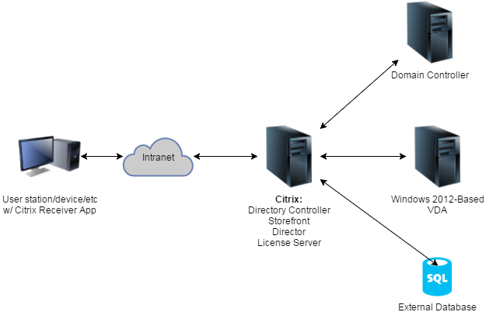
Figure 1: Network Diagram
The VDA enables users to connect to desktops and applications. The user applications are installed on this system. It is installed on server or desktop machines within the data center for most delivery methods.
The Controller manages resources, applications, and desktops, and optimize and balance user connections.
The Storefront serves as a gateway for clients, handles user authentication and access to virtual apps
The License Server manages the product licenses for XenApp

Test Environment configuration:

For our testing, the configuration was as follows:
- Director, Storefront, Studio, and License Server were installed on a Windows 2012R2 virtual machine on a Hyper-V host
- A pre-existing MS SQL2014 SQL server was utilized for hosting the configuration database, as opposed to the default install of MS-SQL
- Integrated into existing testing domain
- VDA (and CIC apps) were installed on a Windows 2012R2 virtual machine on a Hyper-V host
- An existing test CIC 2016R2 environment with Media Server, SIP Bulk Caller testing tool, and a MS Exchange 2013 email server were used for the test back-end.

Functional testing

Basic Functionality
The scope of testing centered on reproducing the actions of end users on the client side as they would perform their daily business tasks using Interactive Intelligence Inc. suite of client-side applications
Basic tests were performed on our mainstream client-side applications to ensure functionality in a Citrix XenApp 7.6 environment. The tested applications all came from the ICUserApps.msi, ICServerManagerApps.msi, and ICBusinessManagerApps.msi packages. Test Cases were selected either to test a specific feature or to ensure that mechanics and presentation of the software performed in the same way as a comparable installation on a standard desktop computer.
Due to the extensive list of product offerings available from Interactive Intelligence Inc. some applications were not tested. These include but are not limited to such applications as Interaction Designer, SOAP Tracer, and Interactive Update Client.
A list of supported applications and applicable configuration notes may be found in Appendix A of this document.

Load Testing

Testing methodology
With the 7.x releases of XenApp, Edgesight is no longer supported for load testing. The Citrix recommended testing software is now LoginVSI (http://www.loginvsi.com/documentation/Login_VSI).
LoginVSI sets up sessions and load tests using MS Office apps, notepad, and other similar apps to generate a load, in addition to your app under test. The evaluation license used for the test had a 20 session limit, so that was used as the base for the benchmark. LoginVSI performs the tests and then determines the optimal number of sessions (VSIMax v4).
One test was performed without Interaction Desktop to establish a baseline. Then, the test was performed with 20 sessions started with Interaction Desktop. Interaction Desktop was set to silent login for the tests.
It is recommended for the customer to perform their own benchmarking as performance will vary with individual configurations.

Load test Results
Neither the baseline of 20 sessions without Desktop running nor the test with 20 sessions running Desktop reached the LoginVSI threshold level. LoginVSI establishes a baseline response level and adds 1000ms to establish the threshold. For both tests indicated, the threshold would be at 1640ms.

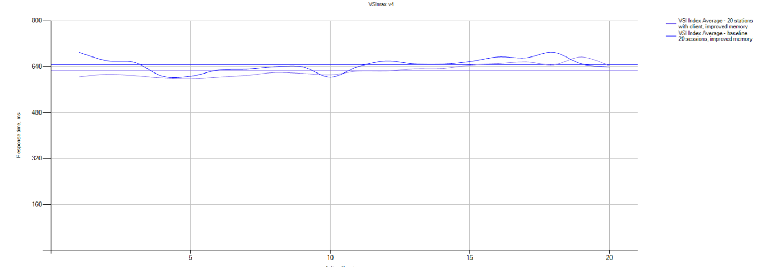

Further analysis of the data reveals that no sessions were stuck during either test, and that the baseline and threshold levels are comparable for our baseline test and 20 sessions running Interaction Desktop

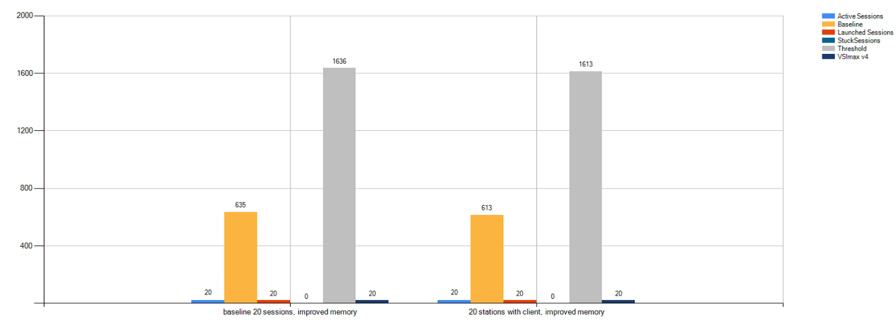

Appendix A: Support matrix and configuration notes

While CIC 2016R2 was the specific version utilized for this test, all R-levels of CIC 2015 and CIC 2016 should be considered supported due to shared codebase. The following is a list of Interaction Center 2016 R2 applications and features that were tested in our XenApp 7.6 test environment:
Application/Feature | Supported | Notes
Interaction Desktop | Yes
Interaction Voicemail Player | Yes
Interaction Fax Viewer | Yes
IC Server Manager | Yes
Interaction Process Automation | Yes
Interaction Administrator | Yes
Interaction Attendant | Yes
IC System Manager | Yes
IC Business Manager: Supervisor | Yes
IC Business Manager: Feedback | Yes
IC Business Manager: Recorder | Yes
IC Business Manager: Reporter | Yes
Interaction Screen Recorder | Yes | See Interaction Screen Recorder Configuration section of this document

Interaction Screen Recorder Configuration:
When using Interactive Screen Recorder with XenApp, you must create a batch/cmd file to start the screen capture client along with the InteractionDesktop client. The screen capture executable, ScreenCaptureClientU.exe, must be started before InteractionDesktop.exe.

The batch file would then be added by using the “Add Applications Manually…” button on the Application selection screen in the XenApp “Create Application” wizard.

The batch file used in testing for Screen Recorder was as follows:

@echo off
"C:\Program Files (x86)\Interactive Intelligence\ICUserApps\ScreenCaptureClientU.exe"
"C:\Program Files (x86)\Interactive Intelligence\ICUserApps\InteractionDesktop.exe"

Change Log
The following changes have been made to this document since release.
Change | Date
Initial Release | January 7, 2016

